IT Helpdesk Ticket Scenarios - Troubleshooting & Resolutions

Overview:
This document shows four real-world Helpdesk scenarios I completed using the LevelEffect lab environment using Windows Server, Active Directory and a Windows 10 client machine. These incidents demonstrate core IT support skills including service troubleshooting, SSH configuration, DNS repair, file recovery and account administration.
Each scenario included the original ticket, root-cause analysis and the technical resolution I performed
Scenario 1: Service Failure - SSH Connectivity Issue

Ticket Summary:
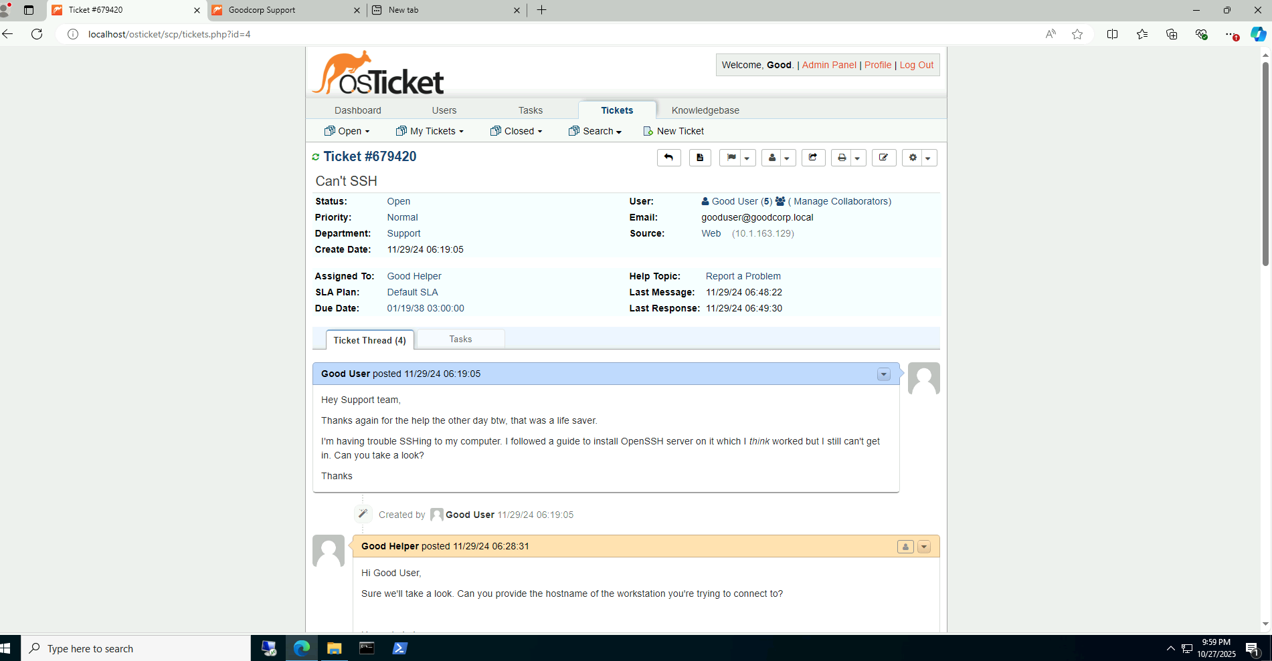

Symptoms:
- SSH attempts failed when connecting remotely
- OpenSSH Server installation uncertain
- User cannot authenticate into the workstation
Possible Causes
- OpenSSH service not running
- Firewall rules blocking port 22
- Misconfigured SSH settings
- Network or IP issues
Resolution (What I did)
- Logged into both the Domain Controller and WS1 Workstation
- Checked the SSH service status and then started it with the command below:
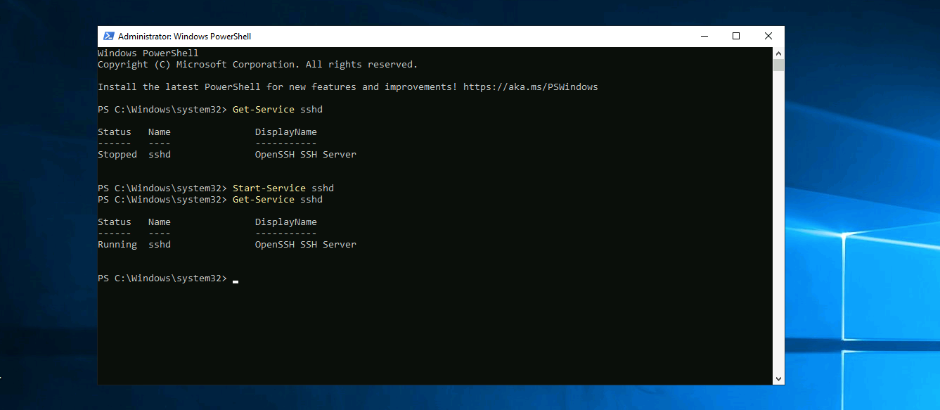
4. After that I tried to SSH into the computer to see if that was the sole problem and it still didn't work.

5 So after that I checked the firewall rules and was able to find that the OpenSSH firewall rule was disabled

6. After enabling this rule, SSH access worked successfully

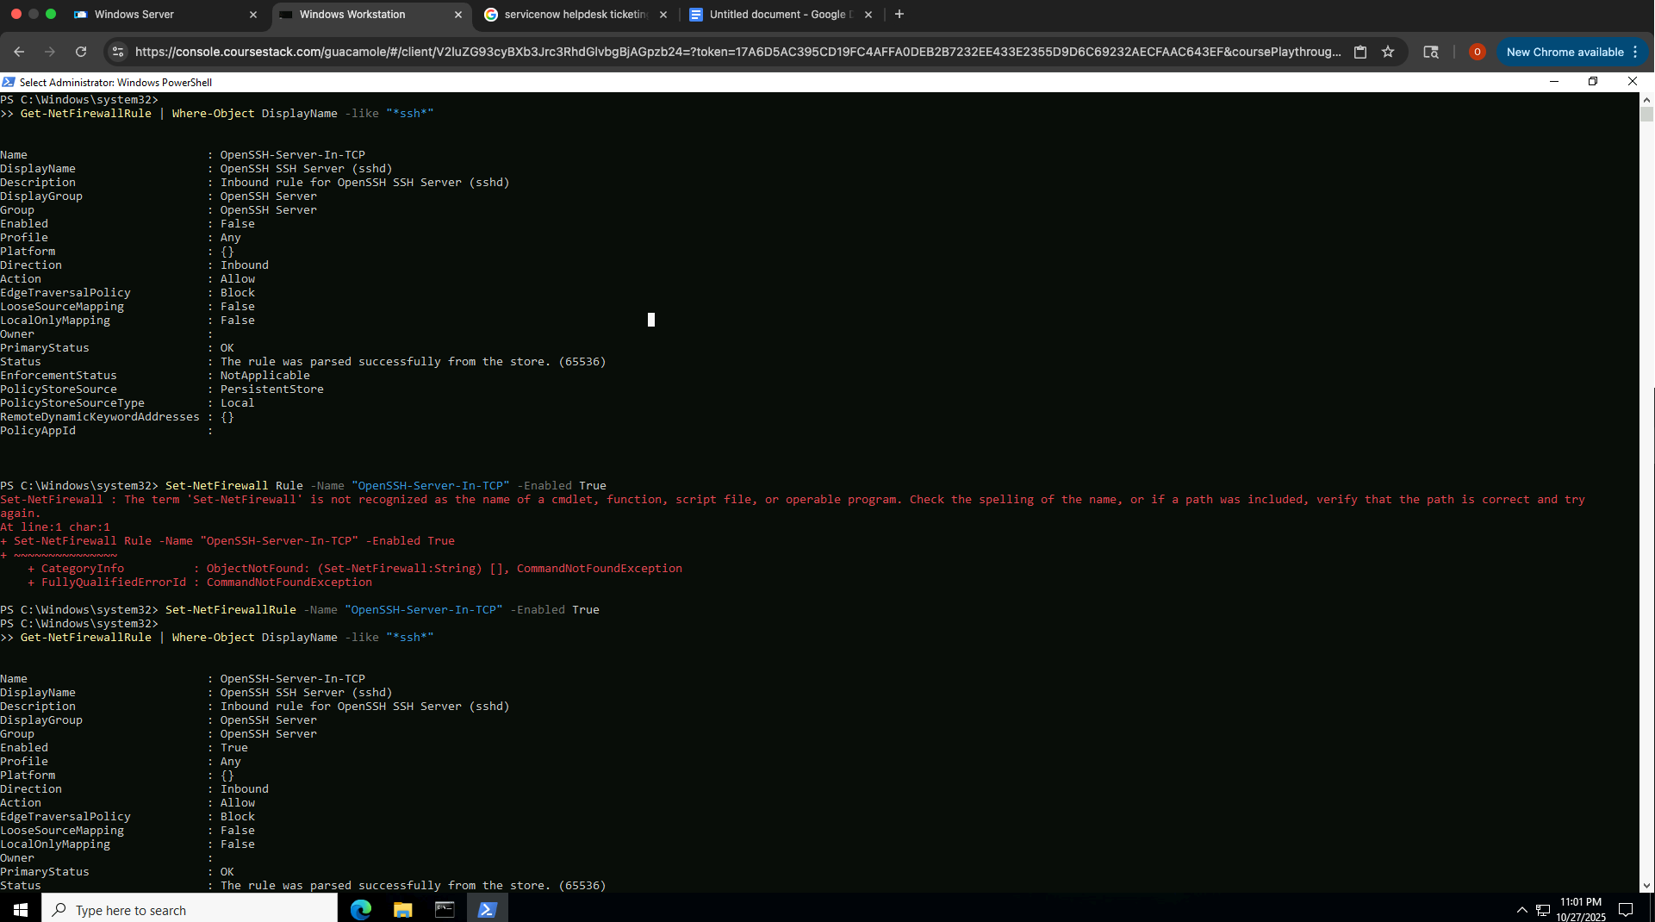
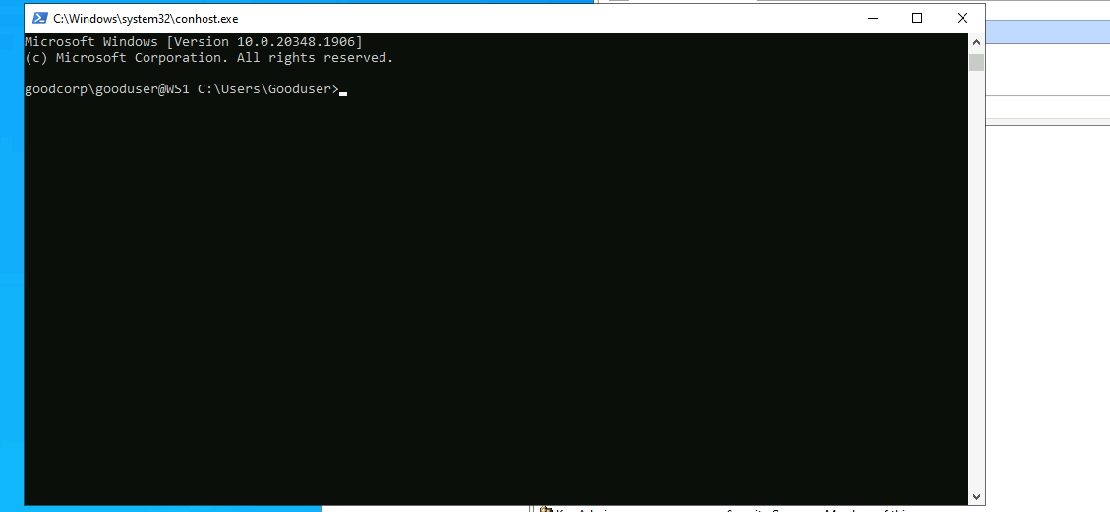

Outcome
SSh Connection was restored and fully functional

Scenario 2: Network Troubleshooting - Cannot Access Websites

Ticket Summary:
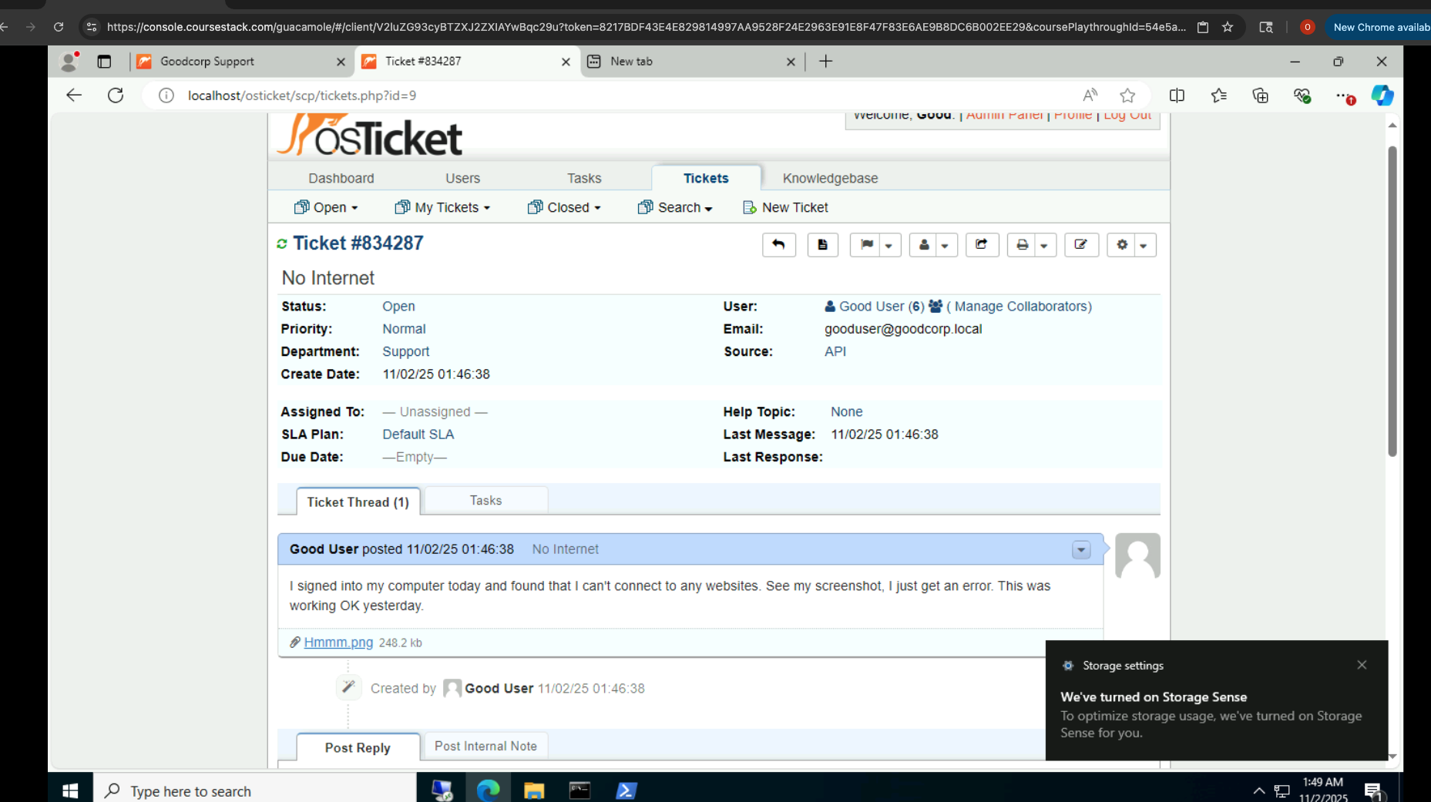

Symptoms
- No websites access
- Browser shows connection errors
- Network interface appears connected

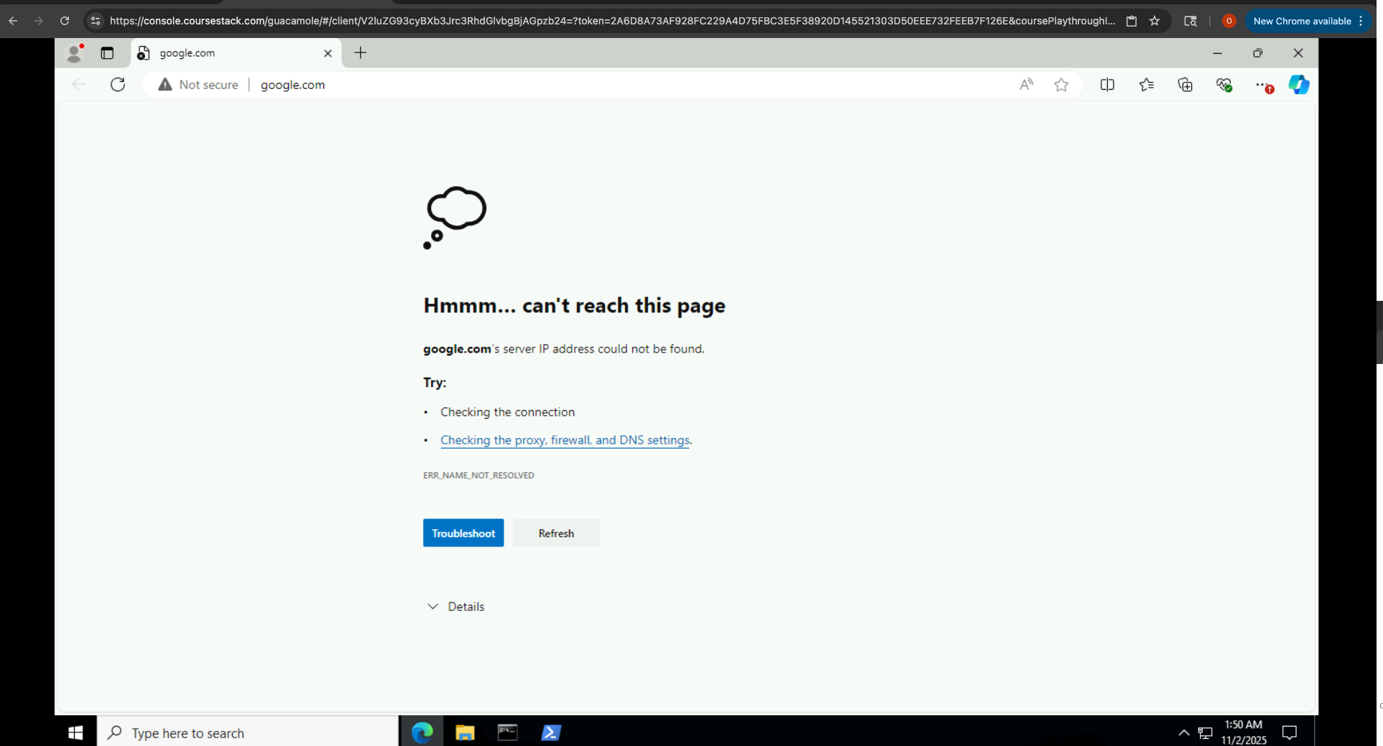

Possible causes
- Incorrect DNS Server
- Wrong IP configuration
- Network adapter misconfiguration
- Proxy settings enabled
- Gateway unreachable

Resolution (What I Did)
- Ran ipconfig /all
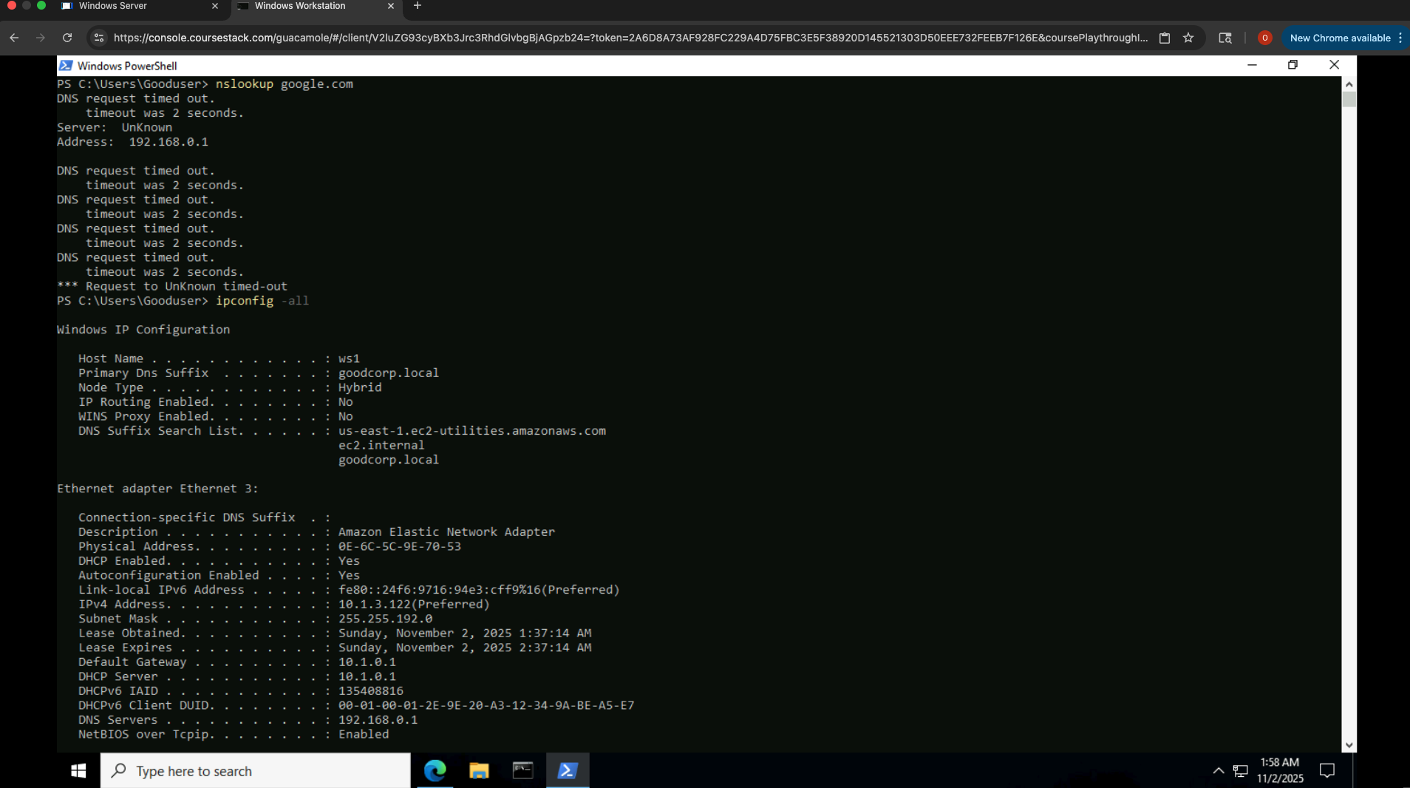
- After running that command I immediately noticed that the workstation had the wrong DNS Server listed. It was not the same as the Domain Controller
- Opened:
- Control Panel
- Network and Internet
- Change adapter settings
- RIght click on the NIC - Properties
- Internet protocol version 4 (TCP/IPv4(
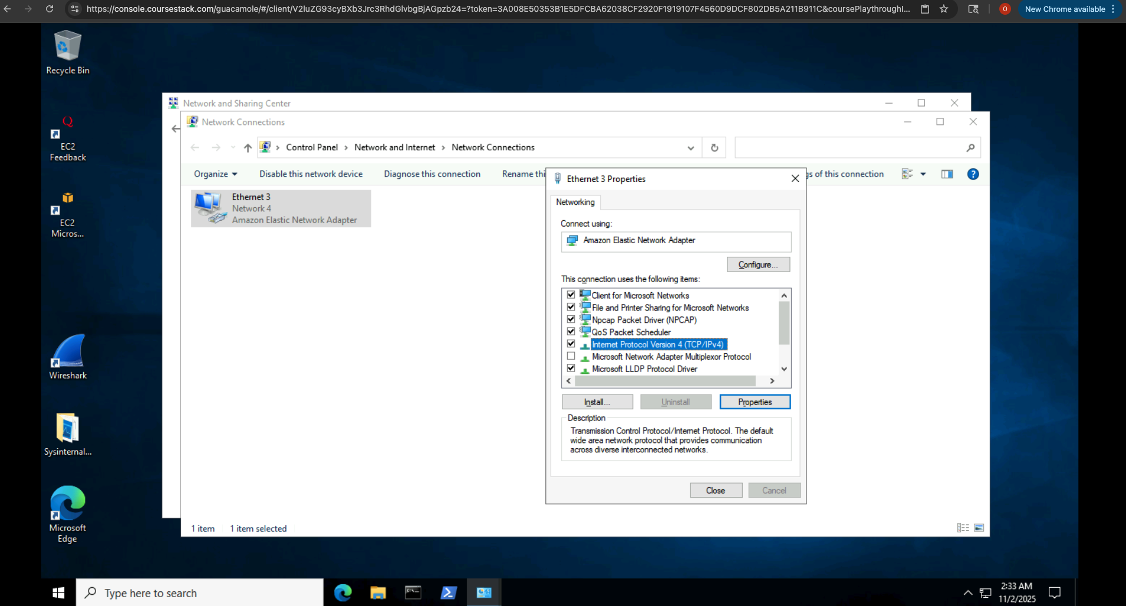

- Updates DNS to point to the Domain Controllers IP ensuring proper name resolution.
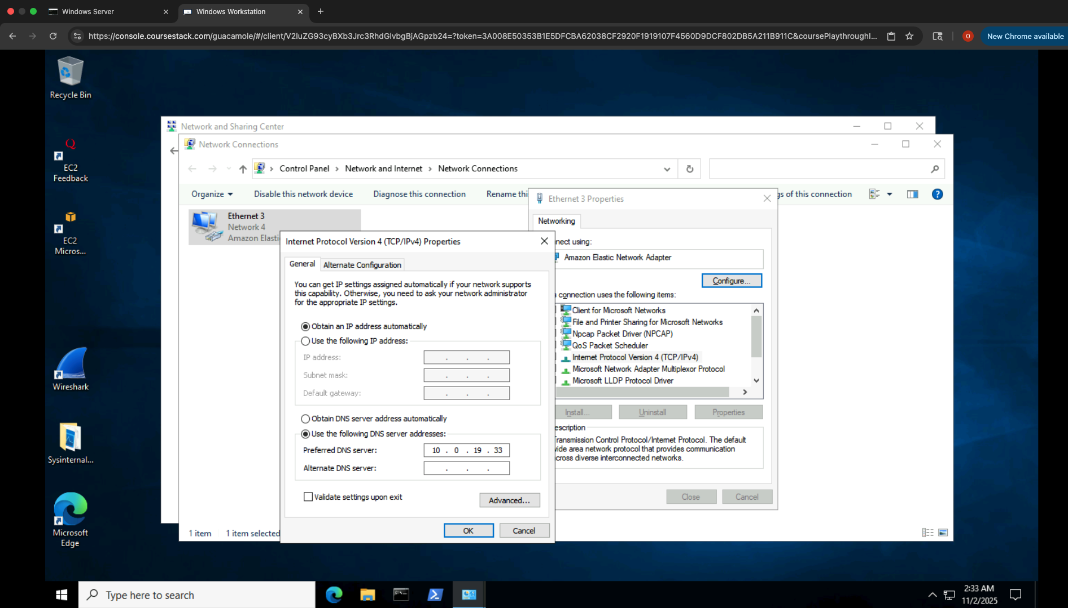
- Saved settings and tested connectivity - internet access restored
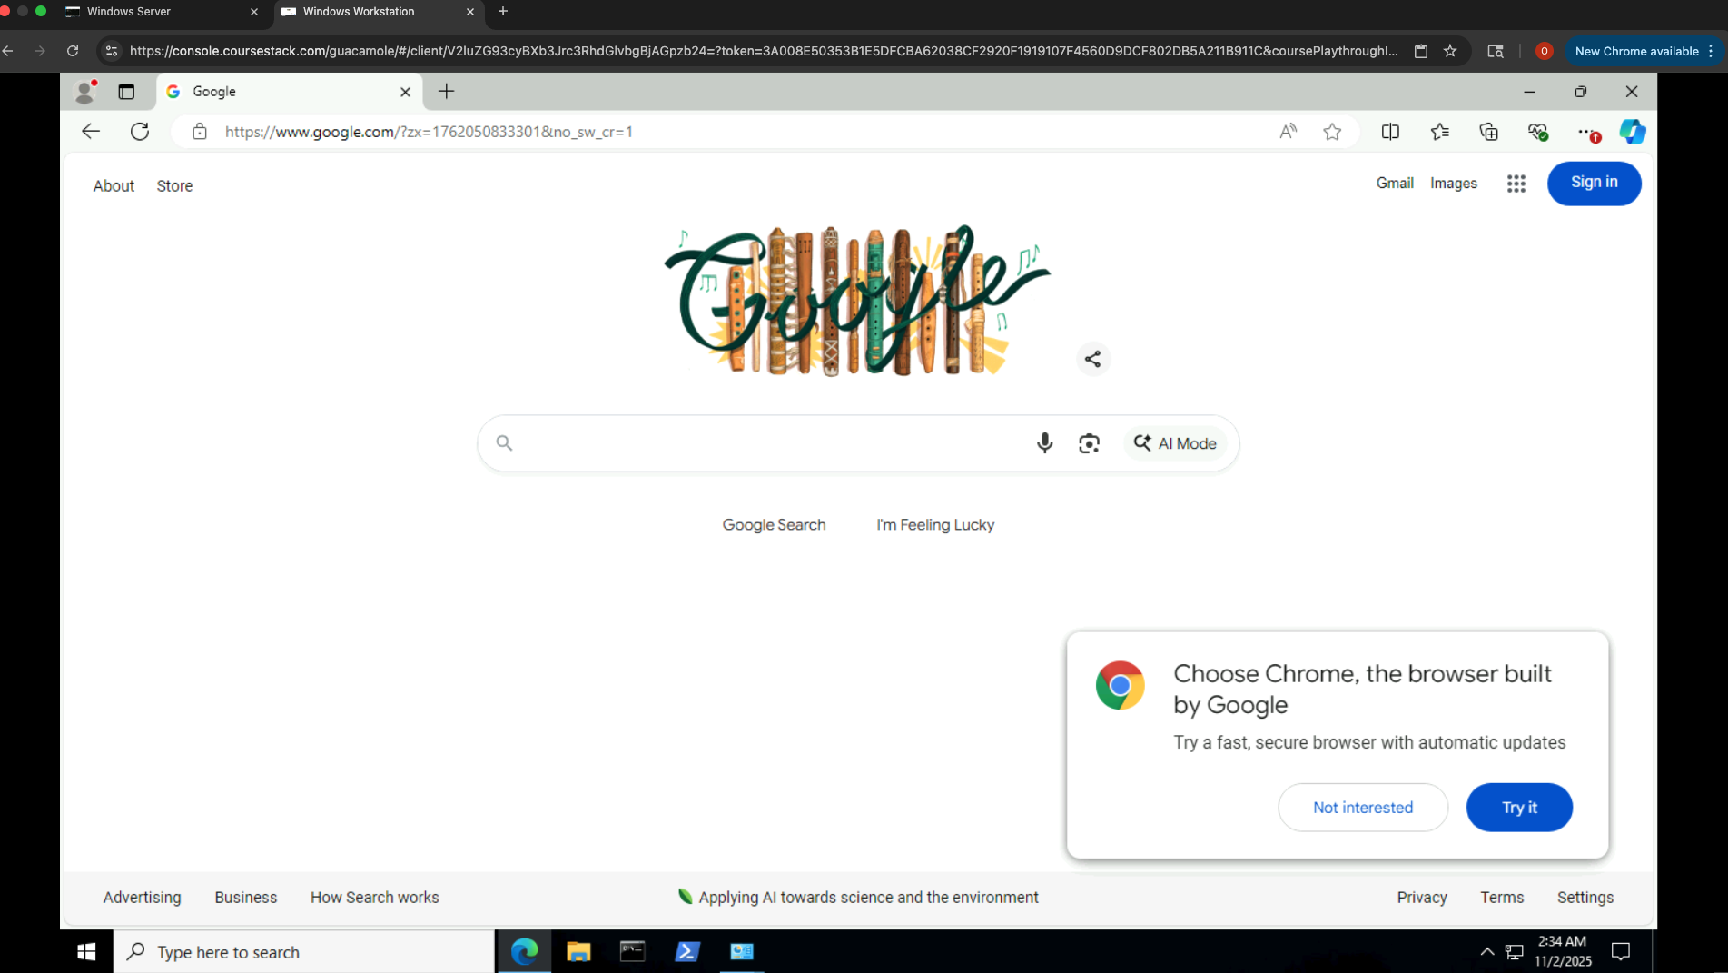

Outcome: DNS corrected, websites loaded successfully and full connectivity was restored

Scenario 3: Lost Data - Shared Folder File Missing

Ticket Summary:
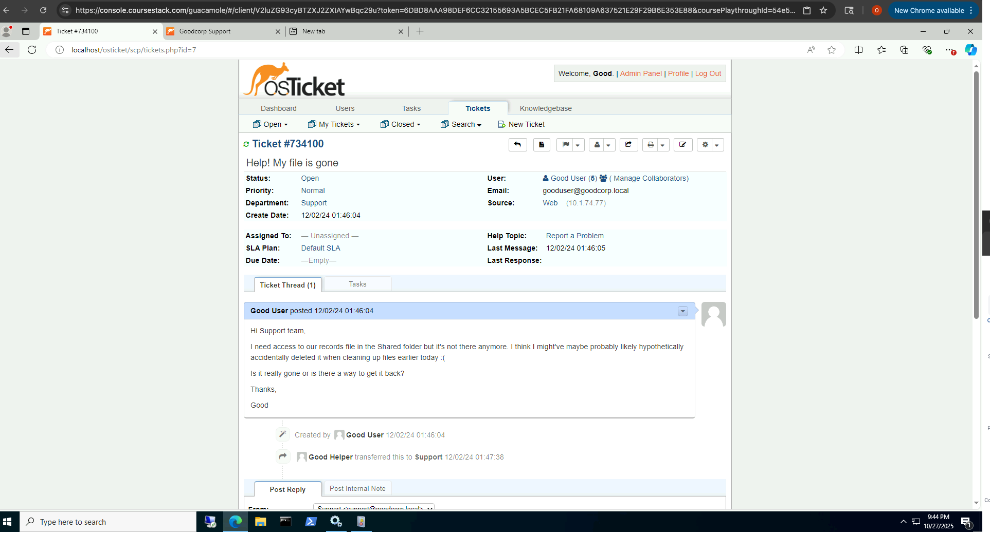

Symptoms:
- Critical shared file missing
- User may have deleted the fil
- Folder permissions appear correct

Possible Causes:
- File deleted by the user
- File moved or renamed
- Network Share permissions changed

Resolution (What I Did)
- Navigated to the shared folder - confirmed the file was missing
- Right click on the shared folder and navigated to the Previous Versions

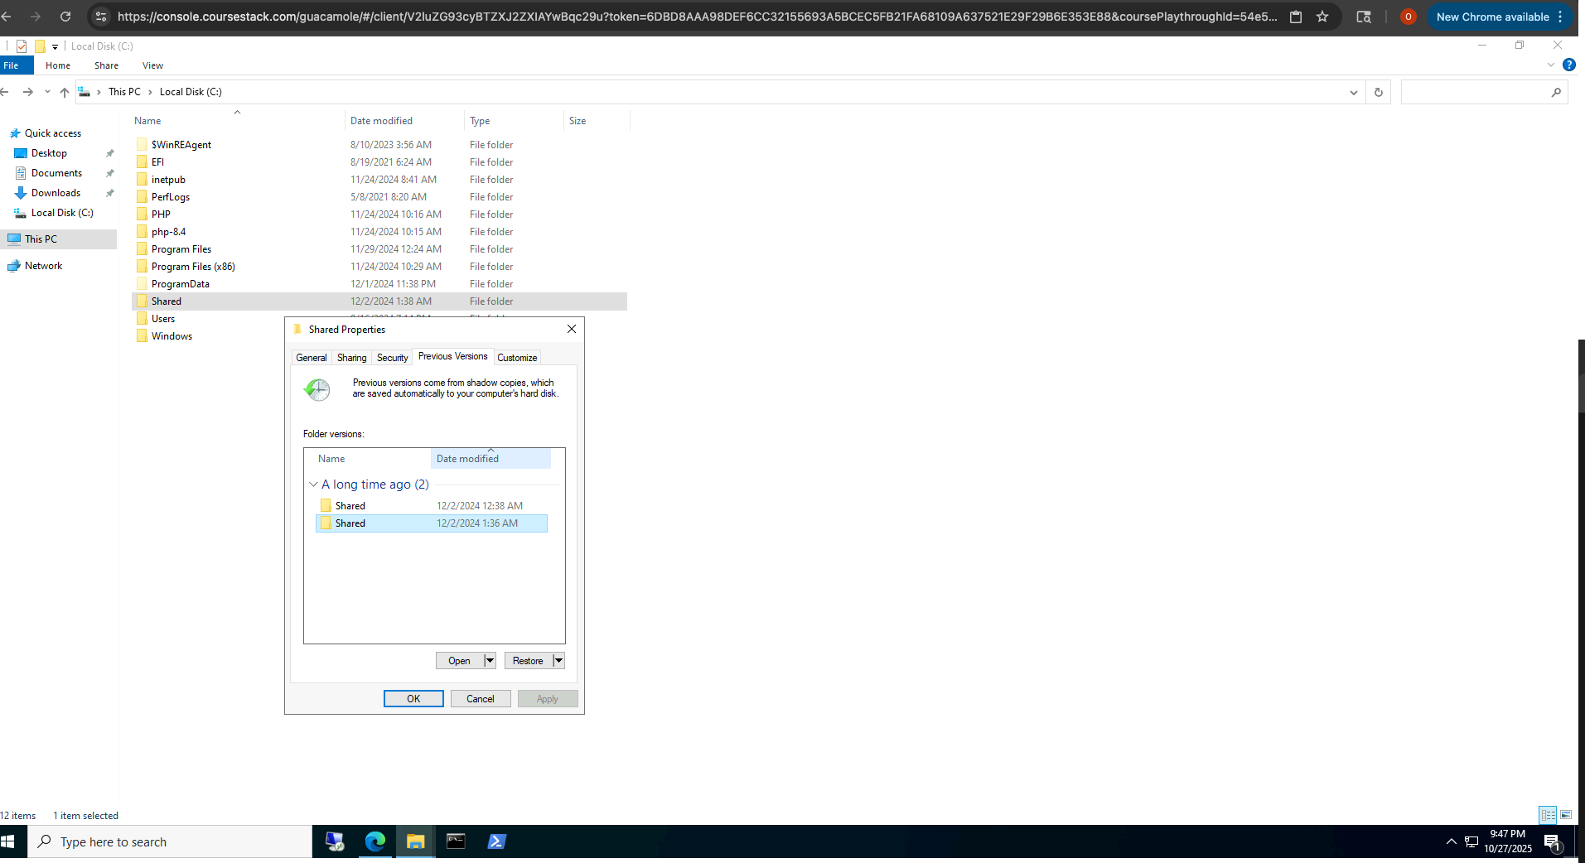

- Located a previous version and restored the previous versions so the user can now access their records.
- Confirmed the records file reappeared and was accessible to the user
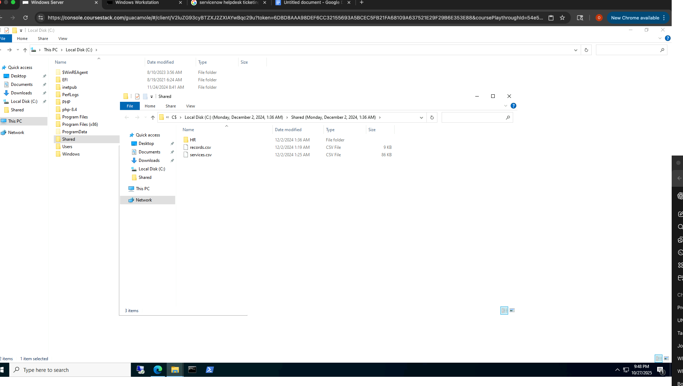
Outcome
The deleted file was successfully recovered using Shadow Copies/Previous Versions

Scenario 4: Brute Force / Account Lockout

Ticket Summary:
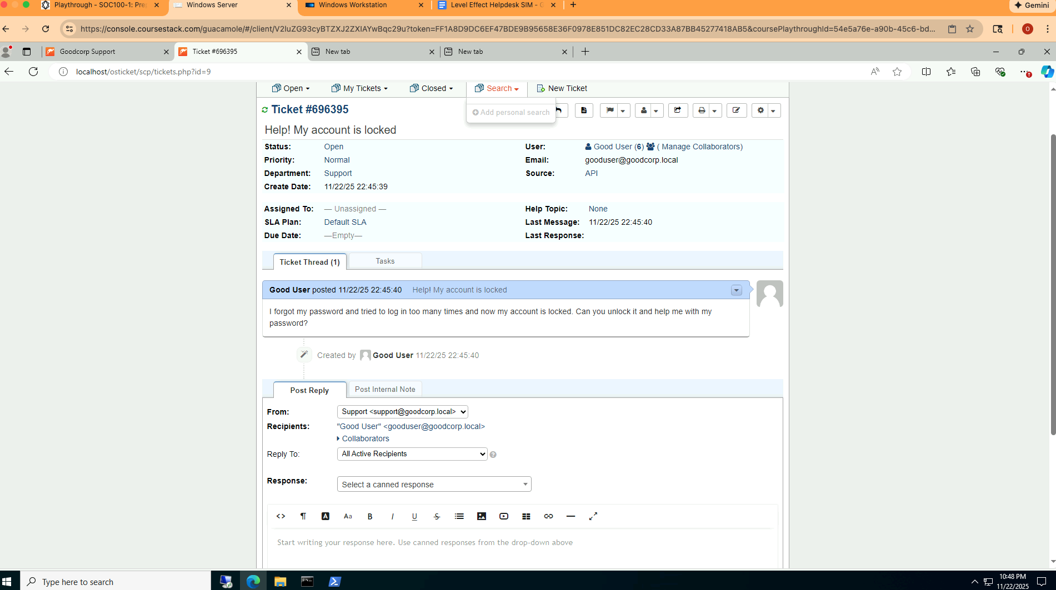
Symptoms
- User locked out of account
- Unable to log in due to AD lockout policy

Resolution:
- Opened Active Directory Users and Computers (ADUC) and found that the gooduser account is locked out.
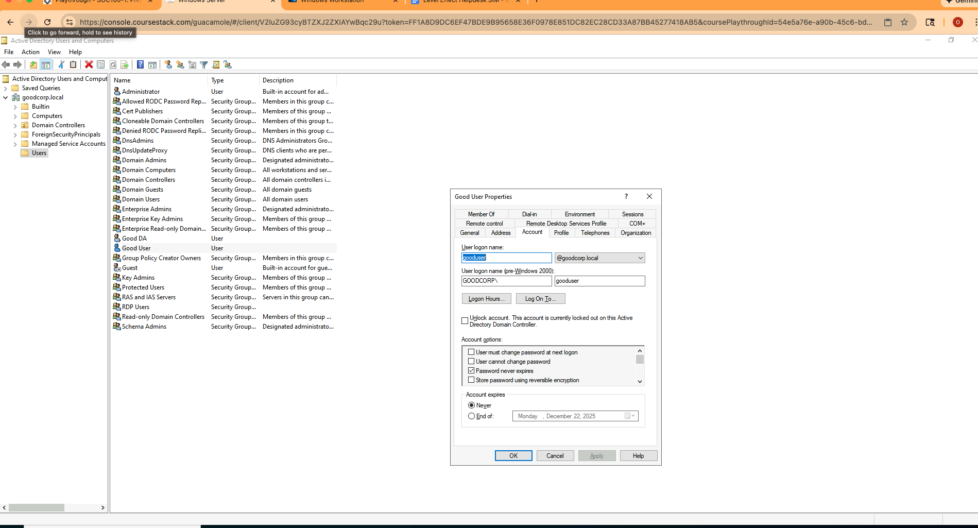

- I unlocked the user account and reset the password to a temporary one and checked the box that said User must change password at next login.

Outcome
User regained access and successfully set a new password

